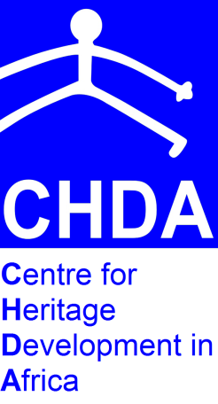
EN-COMPASS: AN INTERNATIONAL DIAMOND OF CULTURAL DISSEMINATION…
Inviting Applications to a Two-Week training workshop at CHDA.

The Centre for Heritage Development in Africa (CHDA), under the auspices of the European Commission’s Investing in People Programme, is partnering with the Newcastle University, UK, the People’s Government of Hainan Province, China and the Iwokrama International Centre for Rainforest Conservation and Development, Guyana on a programme called “En Compass: an international diamond of cultural dissemination and capacity building with countries from the North, East, South and West”.
The project aims to increase the capacity of heritage practitioners ( with a specific focus on indigenous and minority groups) in the participating regions; to identify, safeguard and promote tangible and intangible cultural heritage and to increase the access of local and international populations to different forms of tangible and intangible cultural heritage.

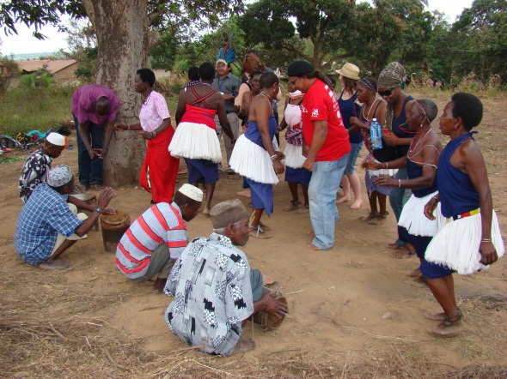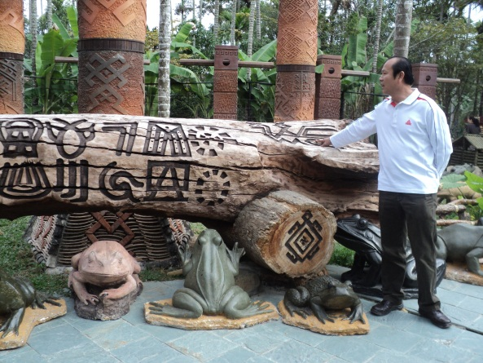
Project activity in Mombasa, with Kaloleni Dancers Cultural heritage resource in Hainan, China

During the first 12 months, the programme has focused on management and promotion of art, music and other cultural expressions through exchanges of heritage practitioners between participating regions, and a scoping, documentation and collection activities in each region. The team of twelve participants is currently curating and developing a travelling exhibition, drawing on heritage resources, cultural products and cultural expressions brought together from the regional activities mentioned above and intended to promote local distinctiveness, cultural diversity and local ownership. Supported by accompanying recorded expressions of intangible cultural heritage, the exhibition will take a tour through the four participating regions as a way of enhancing access to local cultures and protecting and promoting cultural diversity.

In the 12 months beginning September 2011, project activities shall revolve around in-country trainings in Kenya, China, UK and Guyana. These two-week participatory trainings are intended to promote intercultural dialogue, with all participants learning from each other. They will enable an understanding of local expertise and best practices. The facilitators will then work with the participants to disseminate and raise the profiles of local practices and knowledge systems via research outputs and teaching.

Each of the two-week training programmes will involve 15 participants drawn from across the host country/region.
This activity of the project aims at enhancing resource capacity by training local people to a level where they feel confident to take ownership of the cultural resources, practices and expressions and to manage and communicate these to the outside world. A particular emphasis will be placed on meeting the following two objectives: (i) to raise awareness on the role of culture in social cohesion and in fighting all forms of discrimination, including those accepted by customary law; and, (ii) to promote the exchange of expertise and best practices between cultural actors and promoters.

The in-country training in Kenya shall take place in two weeks striding late November and early December 2011.

You are welcome to submit your application to participate if you are an English-speaking heritage practitioner from one of the African countries served by CHDA (please see www.heritageinafrica.org) and if you believe you meet the selection criteria listed below:

Venue: CHDA, Mombasa, Kenya
Dates: Last week of November and First week of December 2011
Application deadline: Wednesday 31st August 2011
Apply by: e-mail to chda@heritageinafrica.org or okwarodp@heritageinafrica.org A one page covering letter should briefly indicate why you think you qualify, what value you bring to the training and what benefits you will gain from participation. Please attach CV/profile and other necessary supporting documents.

CONSIDERATIONS FOR SELECTION

- The applicant should be a practitioner (in private or public heritage sector, including museums, performing arts, visual arts, handcrafts, e.t.c.
- Demonstrate commitment and future impact on the heritage, culture and arts sectors, both in the home countries and internationally;
- Attempt shall be made to balance female and male participants
- Preference will be given to applicants representing groups, communities or associations
- Preference for applicants representing/or demonstrating understanding of indigenous and ethnic minority cultures and arts.
- Ability to effectively write and speak English language is mandatory
- Those who have not previously benefited from CHDA programs shall be given preference

